**Project - Recreation of Cholera Map by Dr. John Snow using D3**

**Developed By:** Aishwarya Kholkute

**Overview:** The project uses D3 to recreate the Cholera Map by Dr. John Snow in 1854 that was a breakthrough in identifying the cause of Cholera epidemic in London.

**The Design Process:**

The Flow Chart indicate the approach:

Start

Construct Map & add pumps

Plot Deaths on Map/ Add functionalities to show deaths by Age / Gender

Verify Color Compatibility for Color Blindness & choose design palette

Plot Death Timeline chart/ Add Hovering functionality

Add separate pie charts for Deaths by age & Deaths by Gender

Add Details to Map/ titles/ legends/Documentation/Video Demonstration

End

**Design Implementation:**

While designing, the most important goal was ability to derive inferences from the graphics, avoiding overuse of/ too many colors, choosing color blind compatible colors. The charts are arranged in a four-quadrant method instead of one below the other, so as to reduce scrolling from top to bottom of the page. The timeline graph and cholera map are placed beside each other since their interconnectivity had to be displayed. The other two are supporting charts, hence placed below the main two charts. The Cholera Map is placed on right since on the left, the buttons & legends are adjusted and a smaller chart (timeline graph) fit in there perfectly. Since the area of Map chart is largest, it maintains the status of focus of webpage.

**Initial Plan:**

Initial ideas were to create a layout as below, however during construction of each element, it became easier to place as per the current setting.

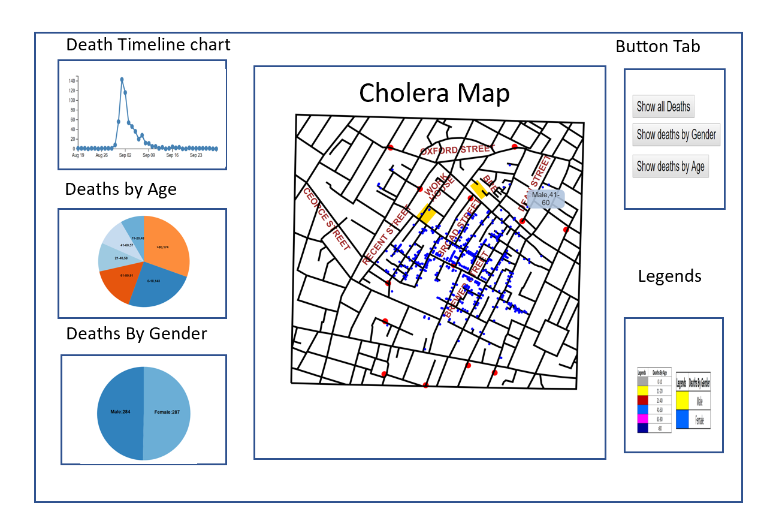

**Interpretation of the results:**

As indicated in Map, a lot of deaths have happened around one particular pump on broad street, thus indicating the primary culprit for the Cholera epidemic was the water through that pump. Minimal deaths around brewery supports the hypothesis that since the workers drank beer, which used boiled water, thus killing the bacteria responsible making it safe to drink. The timeline graph indicates the majority of deaths occured in the period 31st August- 8September, and the proportion of deaths on either sides of the interval was considerably low. The deaths by age chart indicates that people older than 80 years are the most affected category followed by young children. This indicates which age groups are more susceptible to the disease. The gender graph indicates that men and women are equally affected.